

***INSTITUTE OF INFORMATION TECHNOLOGY***

***JAHANGIRNAGAR UNIVERSITY***

**Number of Assignment :** 01

**Submission Date :** 08/04/2024

**Course Tittle :** Machine Learning

**Course Code :** ICT - 4261

**Submitted To Submitted By**

Dr. Jesmin Akhter Md. Shakil Hossain

Professor Roll – 2023

IIT – JU 4th year 2nd Semester

IIT – JU

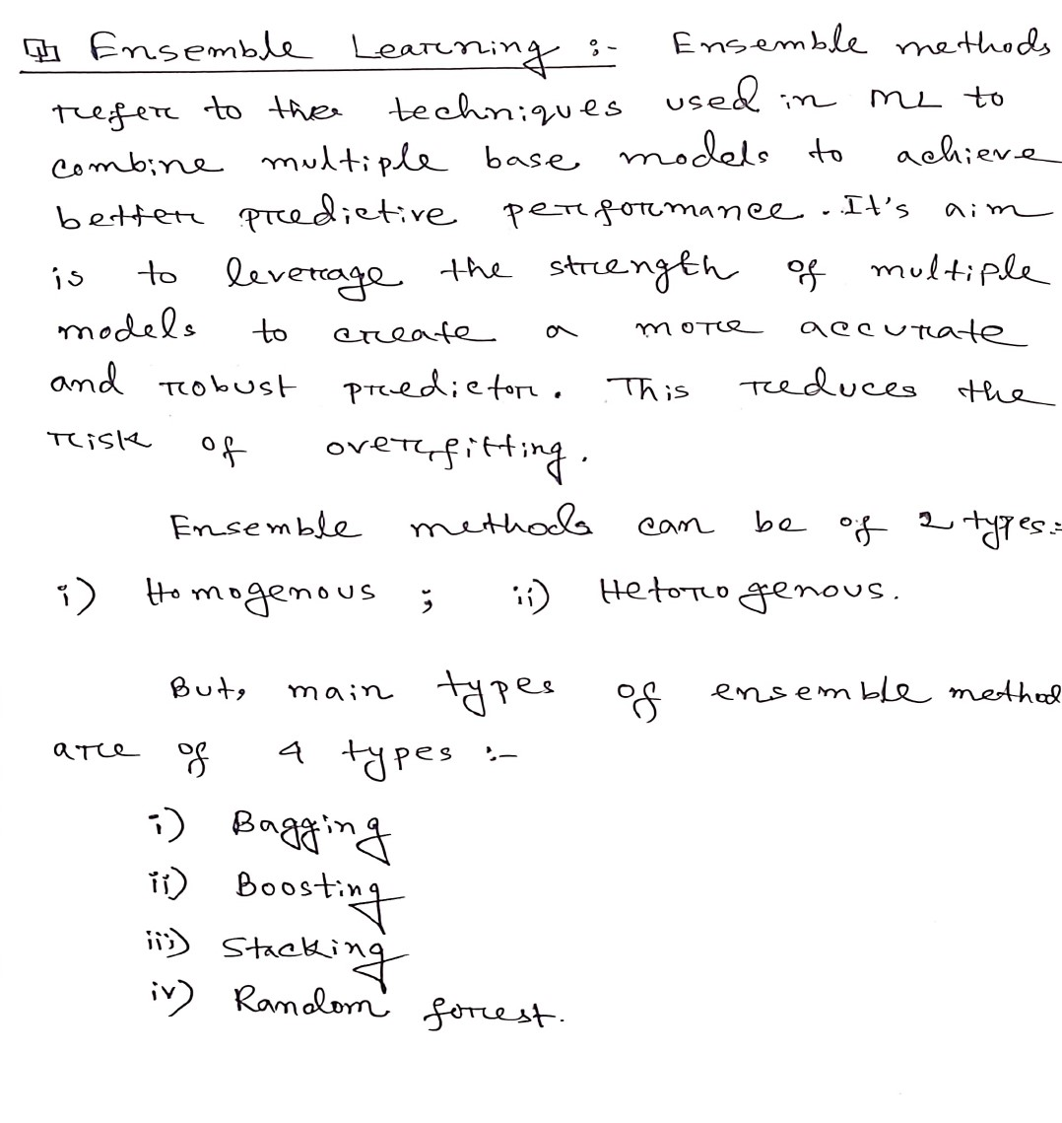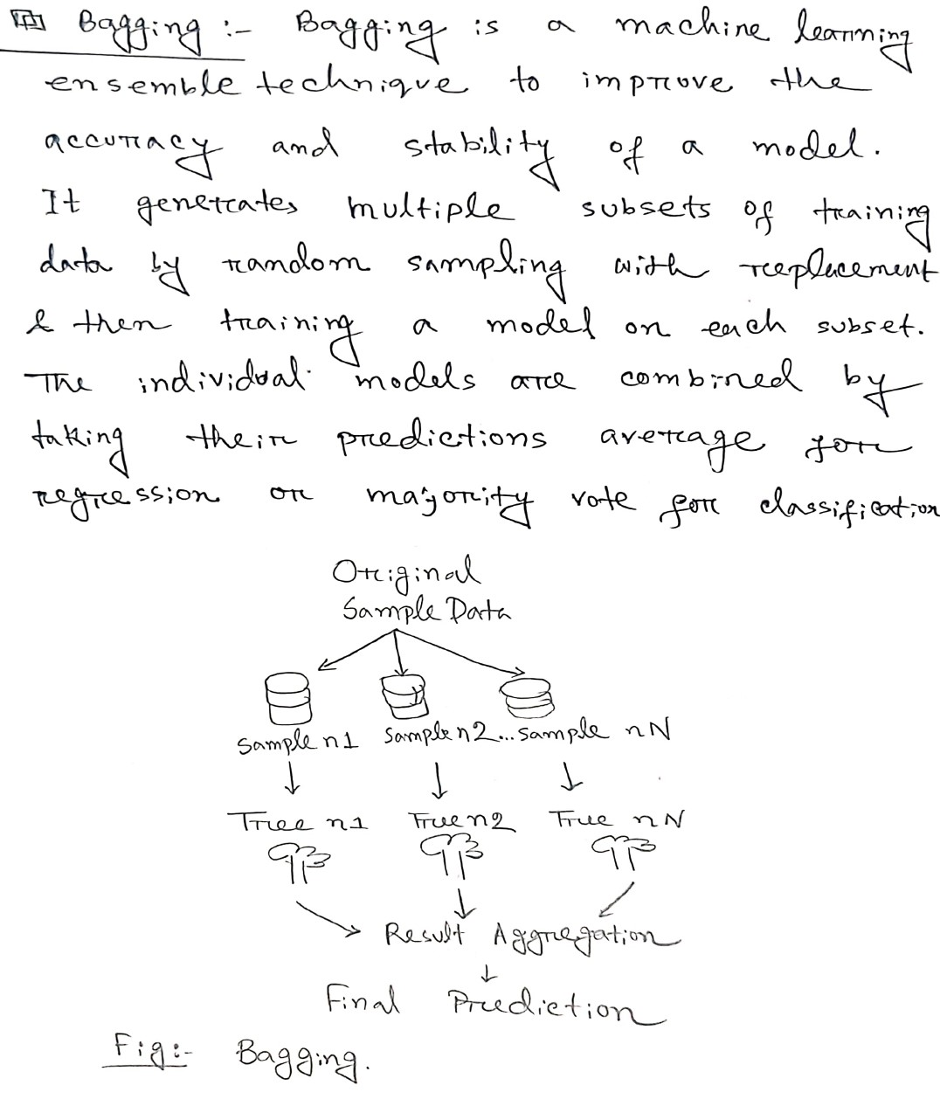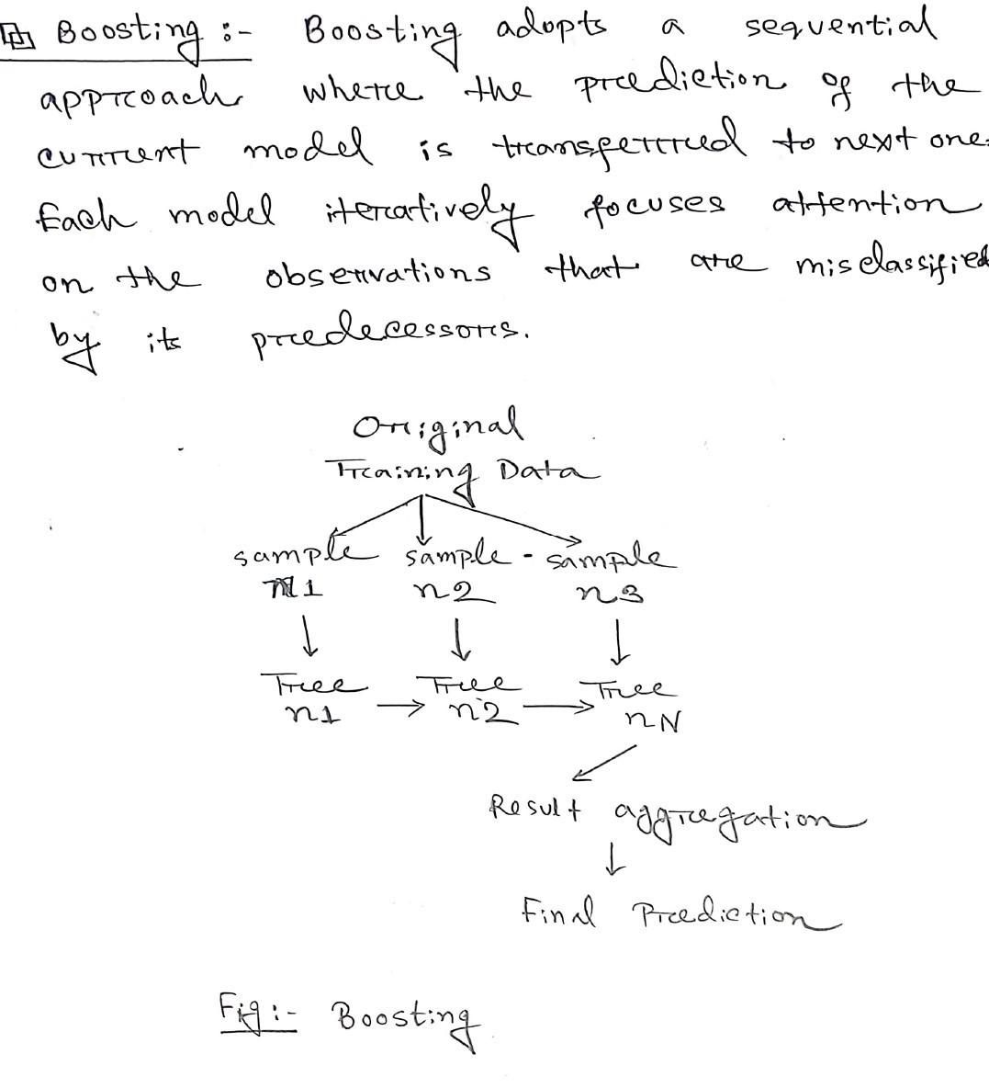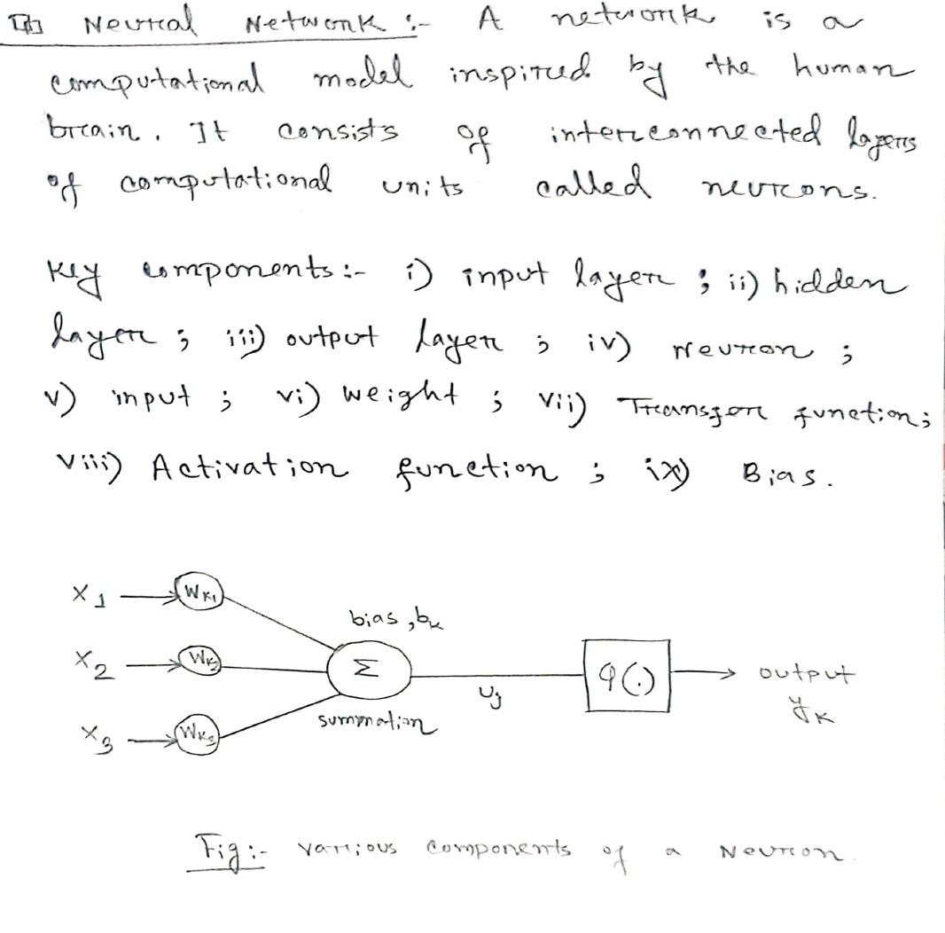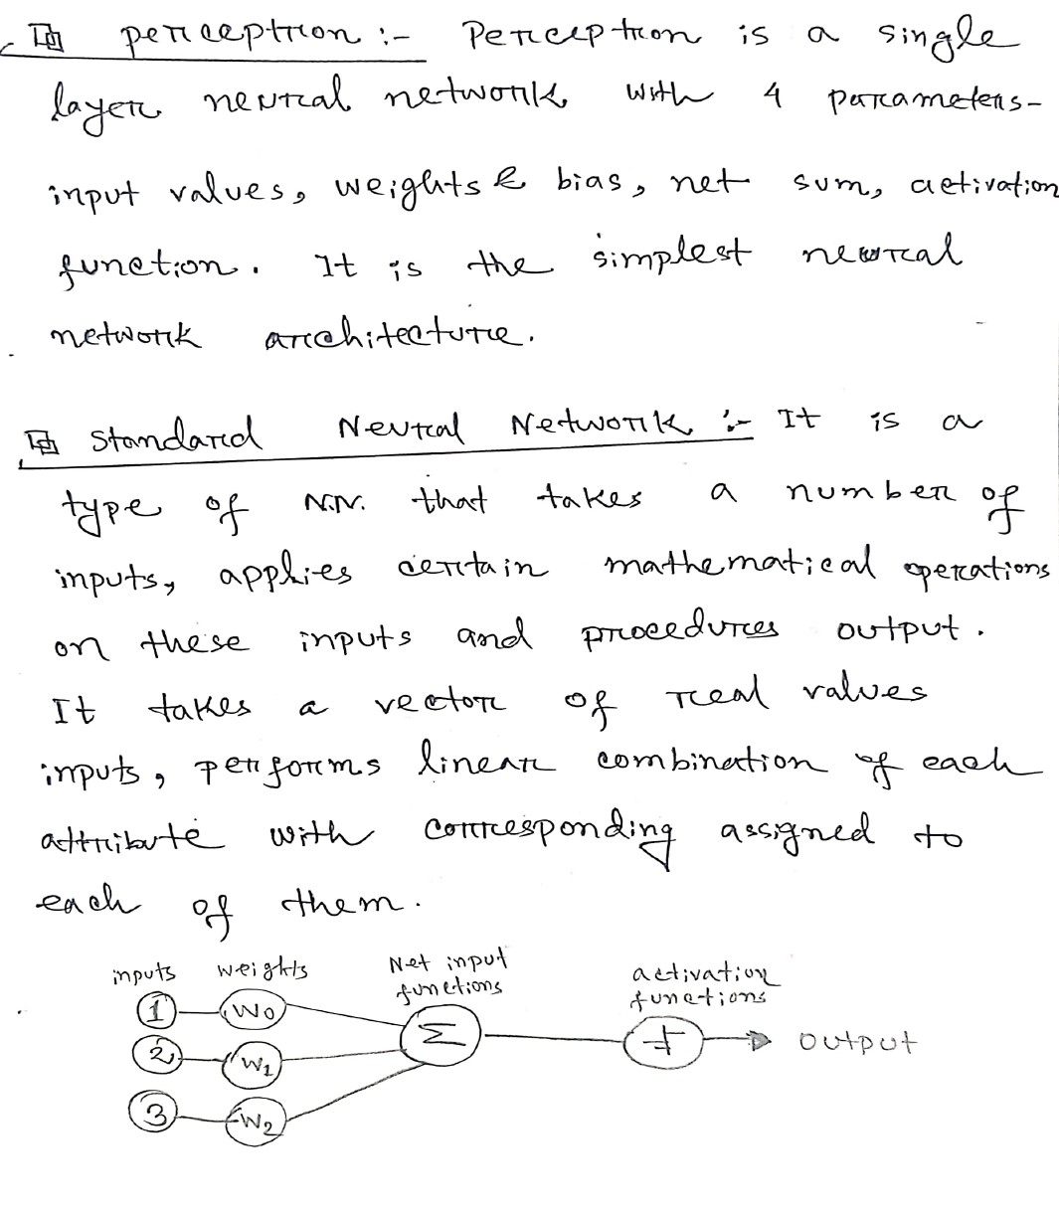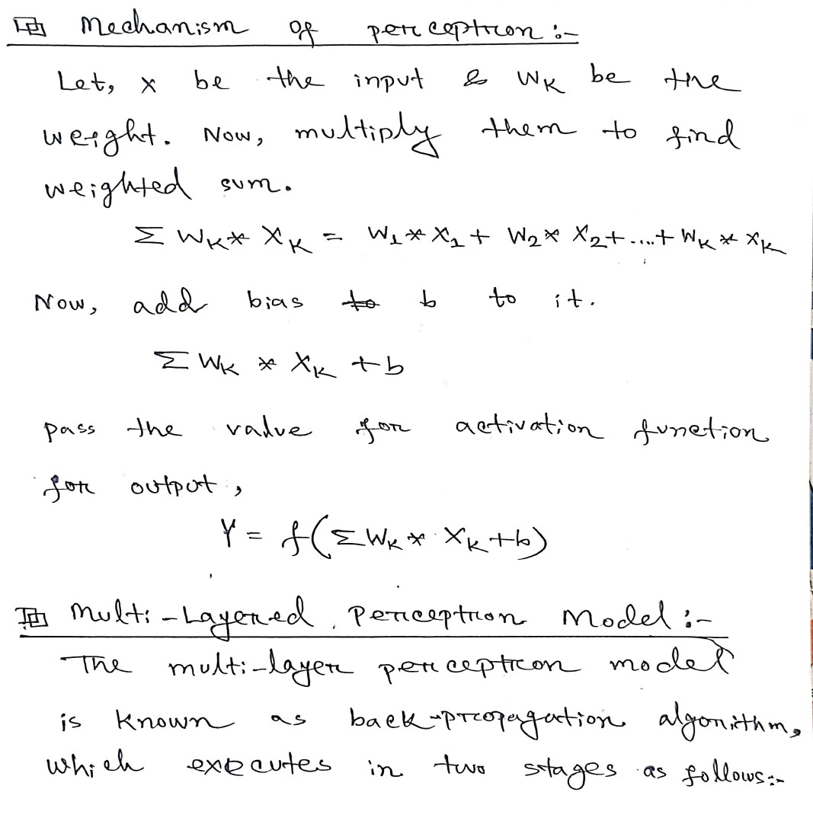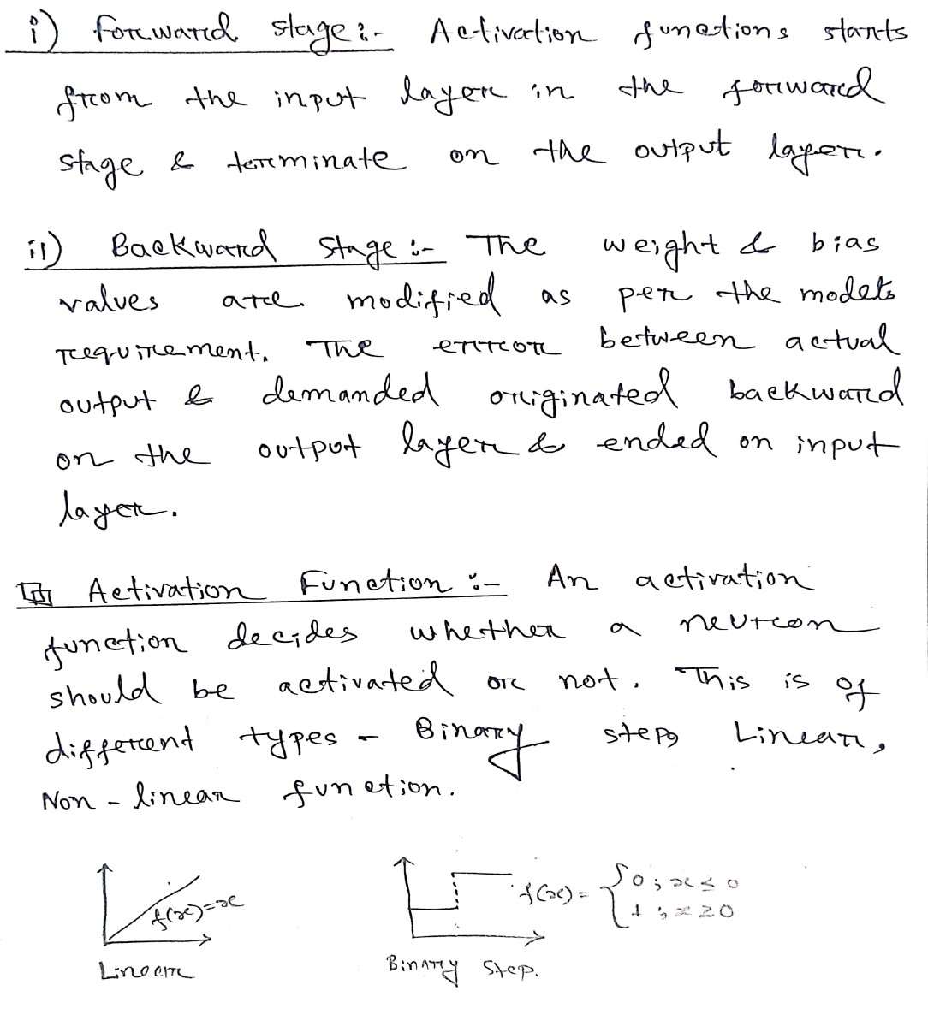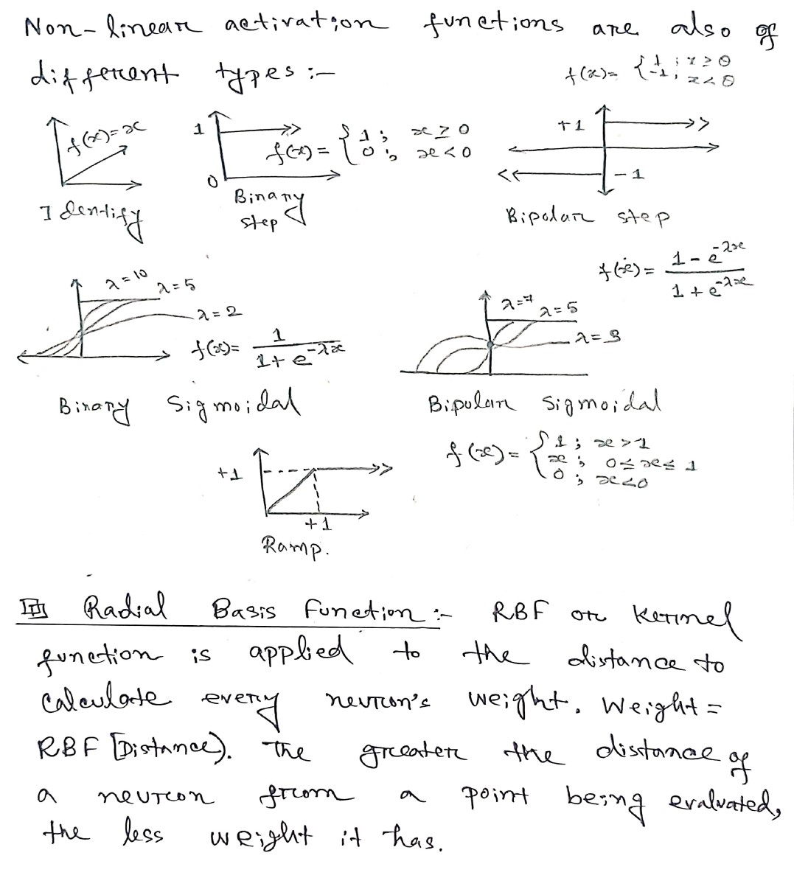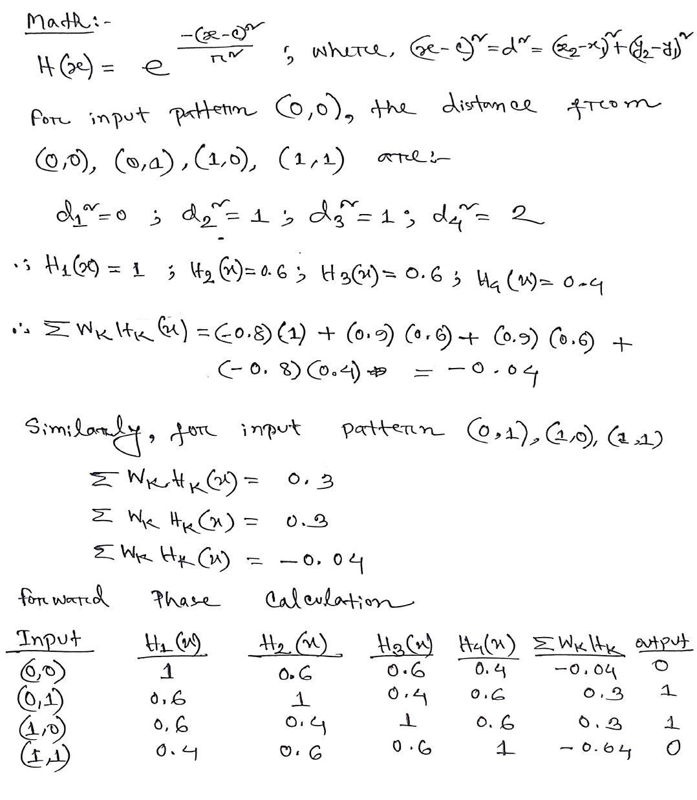

The End